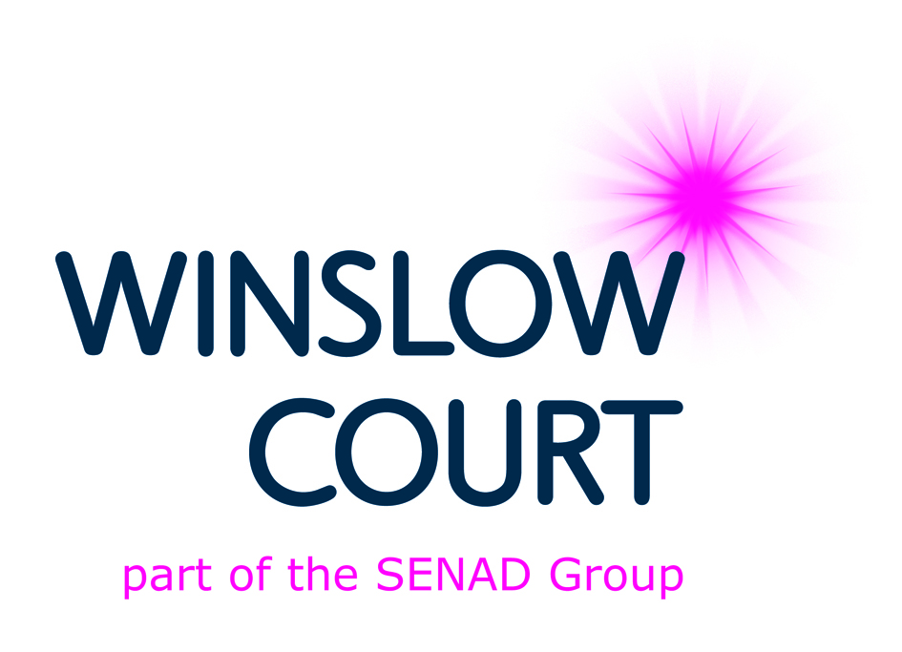

WINSLOW COURT LTD (ONENINEFIVE / ECCLESBOURNE LODGE)

Deputy Shift Manager Person Specification (Jan14)

ESSENTIAL
Skills, Knowledge & Abilities
- Excellent people skills
- Good financial management skills
- Knowledge of company policies and procedures and the ability to implement them across a team of staff
- The ability to work under pressure in challenging circumstances
- The ability to work on ones own initiative and as part of a committed team
- Knowledge and understanding of what the role involves and a clear appreciation of its challenges and its rewards
- An ability to identify and undertake any training necessary to develop within the role and a commitment to achieving mandatory and developmental training and qualifications
- Knowledge and understanding of what a Person Centred Approach means to the resident and an ability to share your knowledge with others
- Knowledge and understanding of the importance of staff and resident Risk Assessments within the work place
- An awareness of company direction and vision and an ability to help achieve that vision.

Experience
- Minimum of one year’s previous experience of working with adults with severe learning difficulties and who can present challenging behaviours.

Personal Attributes
- Good time management and personal organisation
- The ability to develop and mentor a team of support staff to their full potential
- Calm and even tempered, assertive as appropriate
- Willingness to work flexible hours including evenings, weekends, and sleep-in duties
- To have a commitment to and an understanding of the care of those with severe learning difficulties and challenging behaviours
- An excellent value base and an empathetic manner towards people, an ability to apply these attributes to the people that you work with
- A natural respect for the dignity and individuality of each resident and an ability to promote these values within your team of staff
- Discreet, diplomatic and able to treat information confidentially
- A commitment to equality of opportunity at all times and have due respect for the diverse make up of colleagues and those in our care.

Education & Qualifications
- A good standard of written and verbal communication
- A valid current driving licence
- Level 3 Diploma in Care or equivalent
- Up to date mandatory training record.

DESIRABLE
- Previous experience of managing a small team of staff and delegation of workload
- Previous experience of good supervision and supervision training.

